 **Java Technical Training**

**Assignment 1**

1. Create a repository in GitHub and push all source code of all exercises in it?
2. Write a Java program to print "Hello World".

**package** java;

**public** **class** helloworld {

**public** **static** **void** main(String[] args) {

System.***out***.println("Hello World");

}

}

OUTPUT :  
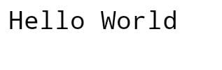

1. Write a Java program for declaring variables of all data types.

**package** java;

**public** **class** declaration{

**public** **static** **void** main(String[] args) {

**boolean** a = **false**;

**byte** b = 10;

**int** c= 34;

**float** d = 67.2f;

**double** e = 12.3;

**char** f = 'A';

System.***out***.println(a + " " + b + " " + c + " " + d + " " + e + " " +f);

}

}

OUTPUT:

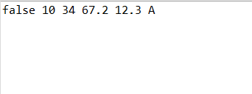

1. Write a Java Program to find size of different data type

**package** java;

**public** **class** size {

**public** **static** **void** main(String[] args) {

System.***out***.println("Size of byte: " + (Byte.***SIZE***/8) + " bytes.");

System.***out***.println("Size of short: " + (Short.***SIZE***/8) + " bytes.");

System.***out***.println("Size of int: " + (Integer.***SIZE***/8) + " bytes.");

System.***out***.println("Size of long: " + (Long.***SIZE***/8) + " bytes.");

System.***out***.println("Size of char:"+(Character.***SIZE***/8) + " bytes.");

System.***out***.println("Size of float: " + (Float.***SIZE***/8) + " bytes.");

System.***out***.println("Size of double: "+(Double.***SIZE***/8) + " bytes.");

}

}

OUTPUT:

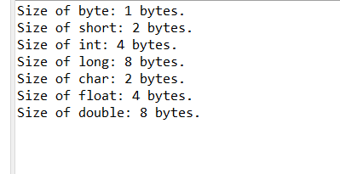

1. Write a Java program to check whether Java is installed on your computer.

Expected Output

Java Version: 1.8.0_71

Java Runtime Version: 1.8.0_71-b15

Java Home: /opt/jdk/jdk1.8.0_71/jre

Java Vendor: Oracle Corporation Java Vendor URL: http://Java.oracle.com/

Java Class Path: .

**package** java;

**public** **class** check{

**public** **static** **void** main(String[] args) {

System.***out***.println("\nJava Version: "+System.*getProperty*("java.version"));

System.***out***.println("Java Runtime Version: " + System.*getProperty*("java.runtime.version"));

System.***out***.println("Java Home: "+System.*getProperty*("java.home"));

System.***out***.println("Java Vendor: "+System.*getProperty*("java.vendor"));

System.***out***.println("Java Vendor URL: "+System.*getProperty*("java.vendor.url"));

System.***out***.println("Java Class Path: "+System.*getProperty*("java.class.path")+"\n");

}

}

OUTPUT:  
